**Batch: B-1 Experiment Number: 4 - TCP Header implementation**

**Roll Number: 16010422234 Name: Chandana Ramesh Galgali**

**Aim of the Experiment: To write a program to implement TCP header.**

**Program/ Steps:**

**Write a program to accept the input in the hexadecimal form (continuous string) and display**

**the value of each field of TCP header.**

**Output/Result:**

**Code:**

**def tcp_header_components(tcp_header):**

**fields = {**

**"Source Port": int(tcp_header[:4], 16),**

**"Destination Port": int(tcp_header[4:8], 16),**

**"Sequence Number": int(tcp_header[8:16], 16),**

**"Acknowledgment Number": int(tcp_header[16:24], 16),**

**"Header Length": int(tcp_header[24:25], 16) * 4,**

**"Reserved Bits": int(tcp_header[25:27], 16),**

**"Control Bits": int(tcp_header[26:28], 16),**

**"Window Length": int(tcp_header[28:32], 16),**

**"Checksum": int(tcp_header[32:36], 16),**

**"Urgent Pointers": int(tcp_header[36:40], 16)**

**}**

**for field, value in fields.items():**

**print(f"{field} : {value}")**

**tcp_header = input("Enter the TCP header in hexadecimal form: ")**

**try:**

**int(tcp_header, 16)**

**tcp_header_components(tcp_header)**

**except ValueError:**

**print("Invalid input! Please enter a valid hexadecimal number.")**

**Output:**

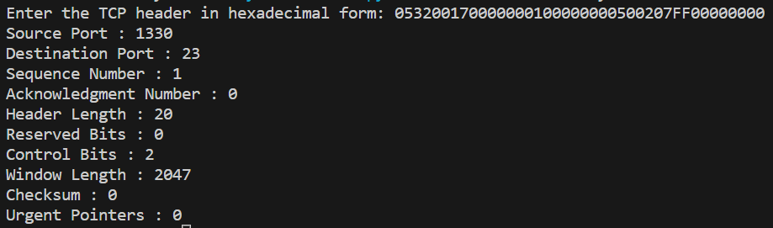

**Post Lab Question-Answers:**

1. The unit of data transfer between two devices using TCP is called TCP segment or TCP packet.
2. Which type of addressing is used at the Transport Layer?

**a) Port addressing**

b) Logical addressing

c) Physical Addressing

d) None of the Above

1. What is the difference between TCP and UDP?

Ans: TCP (Transmission Control Protocol) and UDP (User Datagram Protocol) are both transport layer protocols used in computer networks, but they have some key differences:

1. Connection-oriented vs. Connectionless: TCP is a connection-oriented protocol, which means it establishes a reliable and ordered connection between the sender and receiver before data transfer. UDP, on the other hand, is connectionless and does not establish a dedicated connection before sending data.
2. Reliability: TCP provides reliable data delivery by using acknowledgments, retransmissions, and error detection mechanisms. It ensures that data is received in the correct order and without errors. UDP, however, does not provide reliability mechanisms. It simply sends data packets without any guarantee of delivery or order.
3. Ordering: TCP guarantees in-order delivery of data packets. If packets arrive out of order, TCP reorders them before delivering them to the application. UDP does not guarantee ordering, so packets may arrive out of order.
4. Flow Control and Congestion Control: TCP implements flow control and congestion control mechanisms to manage the rate of data transmission and prevent network congestion. UDP does not have built-in flow control or congestion control mechanisms.
5. Overhead: TCP has more overhead due to its reliability mechanisms, acknowledgments, and sequencing. UDP has less overhead since it does not have these additional features.
6. Applications: TCP is commonly used for applications that require reliable and ordered data delivery, such as web browsing, email, file transfer, and streaming media. UDP is used for applications that prioritize speed and real-time communication, such as video streaming, online gaming, DNS, and VoIP.

In summary, TCP provides reliable, ordered, and connection-oriented communication, while UDP offers faster, connectionless, and unreliable communication. The choice between TCP and UDP depends on the specific requirements of the application or service being used.

**Outcomes: Enumerate the layers of the OSI model and TCP/IP model, their functions and**

**Protocols.**

**Conclusion (based on the Results and outcomes achieved):**

The experiment was successful in achieving its aim of implementing a program to generate TCP headers, and it contributed to our understanding of TCP and network protocol implementation.

**References:**

**Books/ Journals/ Websites:**

1. Behrouz A Forouzan, Data Communication and Networking, Tata Mc Graw hill, India, 4th Edition
2. A. S. Tanenbaum, ”Computer Networks”, 4th edition, Prentice Hall